Innovative Grant Application for High School Student STEM
SED 118
Maria K. Ferguson
September 28, 2021

Student impact:24

Summary:

The Innovation Station will be a collaborative project among science departments which allows a space for high school students to go to learn, develop projects through their curriculum, and allows them to have a place to work hands-on in a collaborative environment which encourages higher level learning and independent thinking. The Innovation Station will need technology which supports research by internet, allows students to watch videos when needed and it will allow the students to develop projects, and use software which support their goals.
Proposal:
In the high school curriculum, the students are learning more detail about chemical structure, bonding and reactions. Lab Kits that provide several AP Experiments will be a resource for students to watch videos and conduct experiments at their own pace. With the experimentation, we are proposing to add modelling kits and a spectrophotometer and computer in which it is interfaced, so that data can be logged automatically and interpreted. In this increasingly technological world in which we live, technology keeps evolving and what was once routinely used in laboratories becomes replaced with a faster, more efficient manner of measurement. This will give the students some hands-on experience with some equipment that has been industry standards.
Description:
It is a goal to acquire modelling kits. Several will be needed that can be used so that individual students will have hands-on time with them. This will allow them to increase their understanding of spatial shapes and angles. This is very difficult to see without models. The students will need workstations so that they can each have time online to view software and videos to accompany their projects. They will also need them for the experimental portion of the curriculum in which they will be measuring and recording data utilizing their Spectrometer. I am requesting one for the entire class and a Spectroscopy—Guided-Inquiry Learning Activities for AP® Chemistry Kit that they can share and use at their own pace.

Modelling kits will be important because even though this is a high school chemistry class, there are students that struggle with a misunderstanding of reaction mechanisms. Incorporating models into the existing classroom should be easy. We already use models, but we can use them to build structures so that the students can see on a molecular level what is happening during a reaction. Expanding the models will help all spatial learners.

Outcomes:

Learning styles are very important on a personal level. Teachers know that not all students learn the same way. Sometimes diagrams help, and sometimes they don’t. Chemical reactions can be somewhat abstract, but building the models makes it more understandable. It can make the difference for those struggling with traditional methods of learning and actually provide a way for students to learn the same material a different way. This also happens when the student actually completes an experiment, observes a reaction take place, and possibly observes a color change or measures a change in pH. Hands-on experiments provide that for the students. With the Lab Kits, students can conduct experiments after watching videos and demonstrations. If they need to, they can rewind and play over again.

Evaluation
1)FlinnPREP™ Inquiry Labs for AP® Chemistry- class and lab time while giving students extra support to help them succeed on the exam. Three of the labs even include simple virtual reality simulations. It all comes together as they apply their knowledge and practice with exam-style questions.(Flinn Scientific, Inc.)
2)Spectroscopy—Guided-Inquiry Learning Activities for AP® Chemistry-The Spectroscopy Guided-Inquiry Learning Activities for AP® Chemistry ensures that students understand the basic principles of each type of spectroscopy. Those principles are then utilized to extract atomic and electron structure knowledge (Flinn Scientific, Inc.)›
3) Atomic Orbital Model Set - You can build with the -s, -p and -d orbitals, build lobes with the orbitals designated.

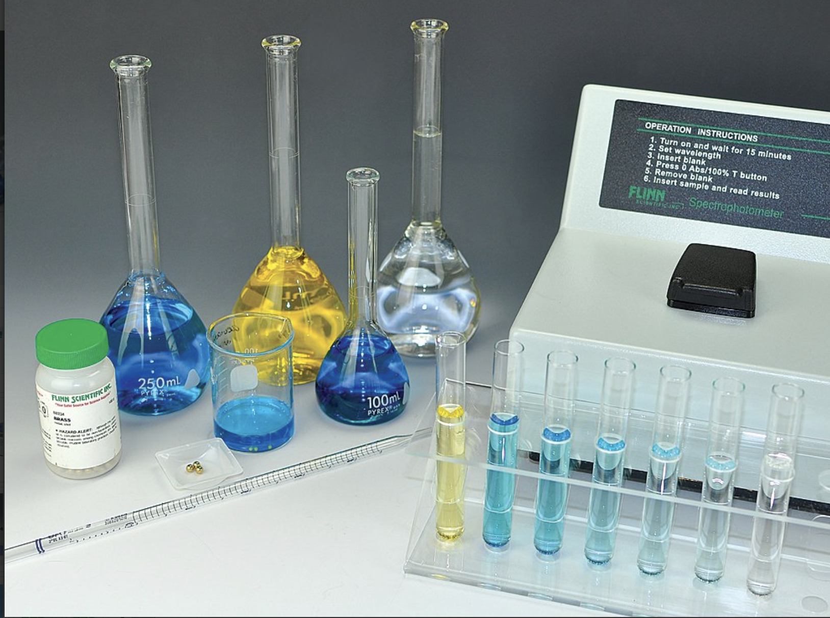

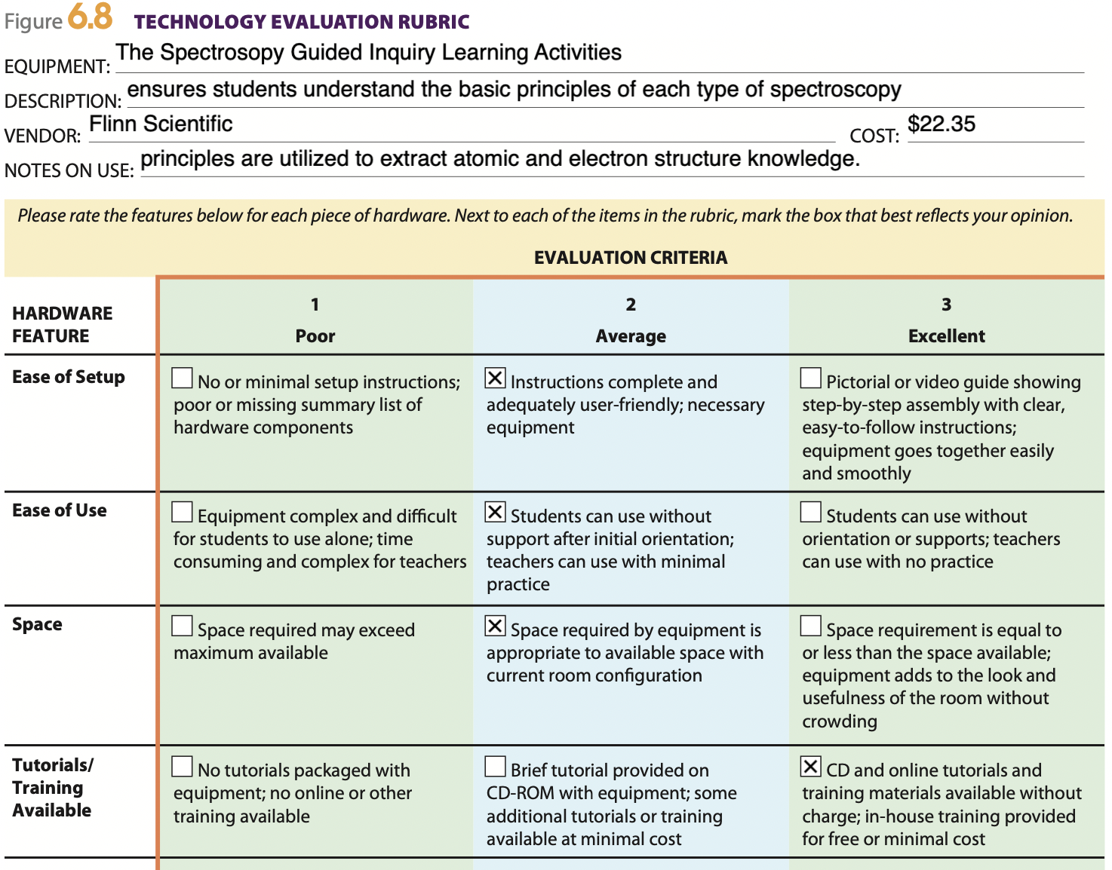
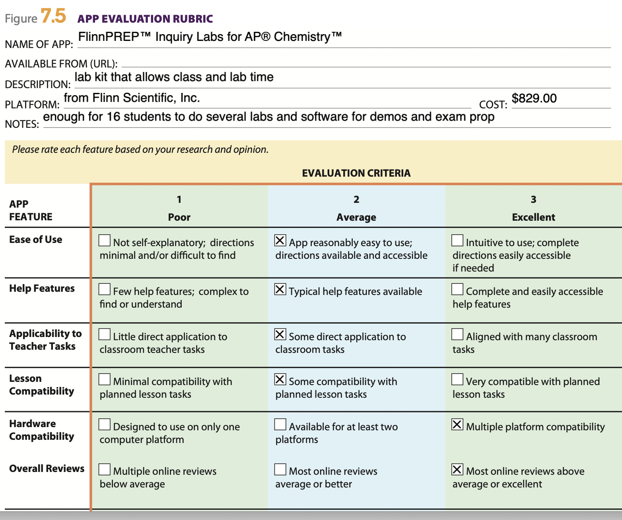

Technology | Cost | Application | Overall Reviews
FlinnPREP for AP Chemistry | $885/16 kits | Includes some simulations and allows students to practice exam questions that are similar to the AP Chemistry exam | Excellent – reagents, supplies and software included
Spectroscopy Guided-Inquiry Learning Activities for AP® Chemistry | $22.35 | Ensures that students understand the basic principles of each type of spectroscopy. Those principles are then utilized to extract atomic and electron structure knowledge | Excellent –software included
Atomic orbital model set | $70.25 | Build -s, -p and -d orbital models with the lobes from electron orbits color coded as well | Great for visual learners.

